**Required Installations**

Activity 1:anaconda

Activity 2: Visual studio

Activity 3:Cmake

Activity 4:Dlib, Face-recognition, Imutils, OpenCV

**Activity 1:**anaconda

1.Anaconda : <https://www.anaconda.com/downloads>

2.Check specific versión based on the system configuration

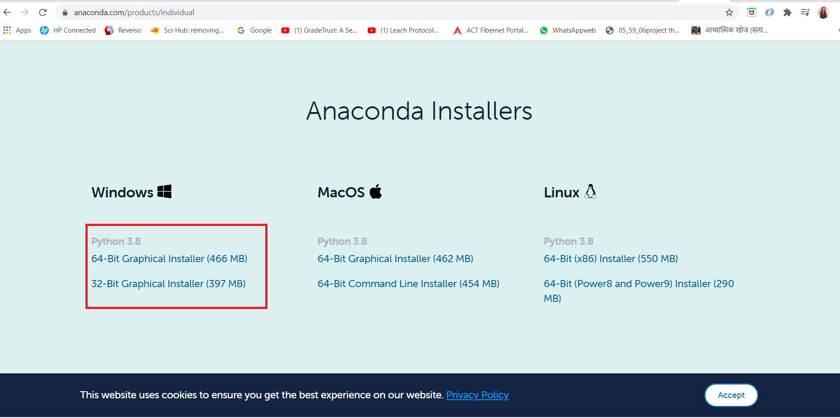

2.After downloading run the .exe file

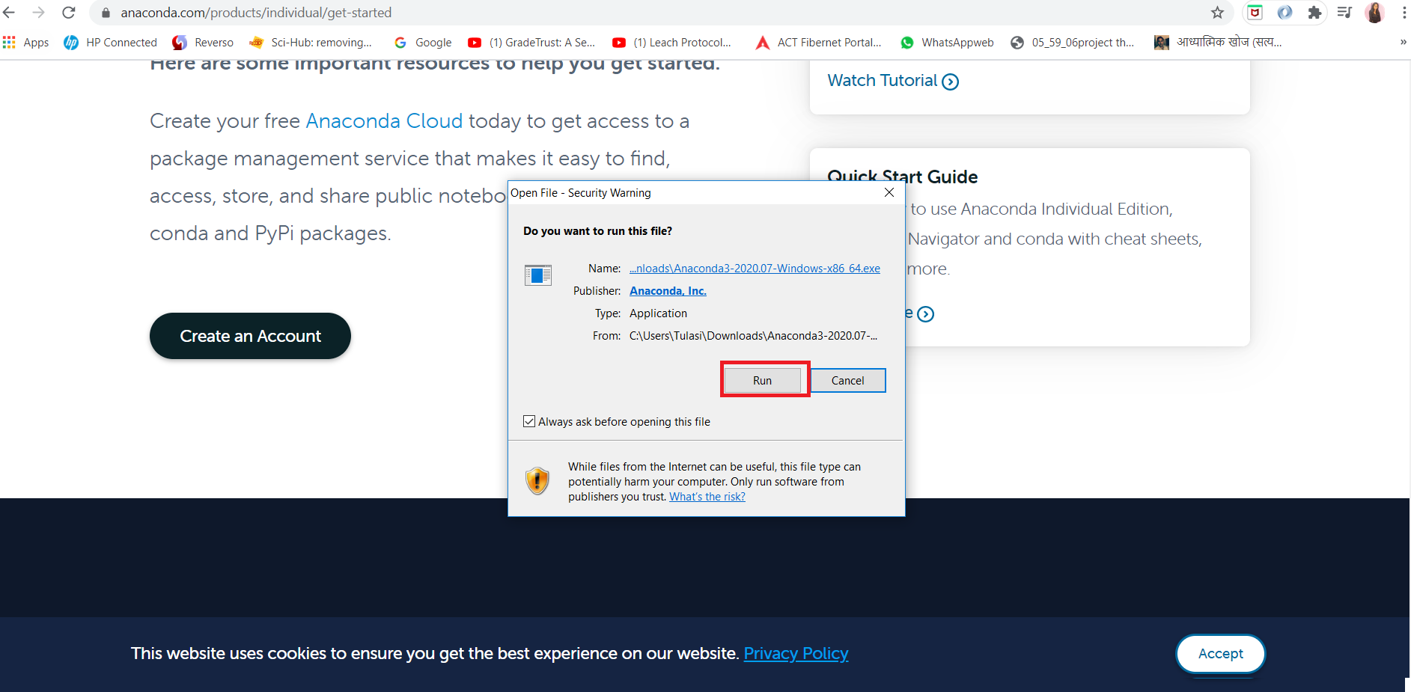

3 .After the installation is complete you can see anaconda prompt,jupyter notebook and spyder in start menu

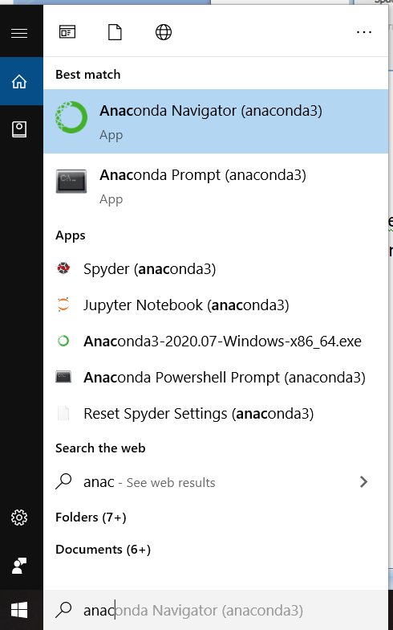

**Activity 2:Visual studio and build tools**

1. Install visual studio <https://visualstudio.microsoft.com/downloads/>
2. Please follow this video <https://www.youtube.com/watch?v=y188HoZbSDE>

(Make sure you select Visual C++ Build tools)

**Activity 3:Cmake**

1. Install Cmake <https://cmake.org/download/>

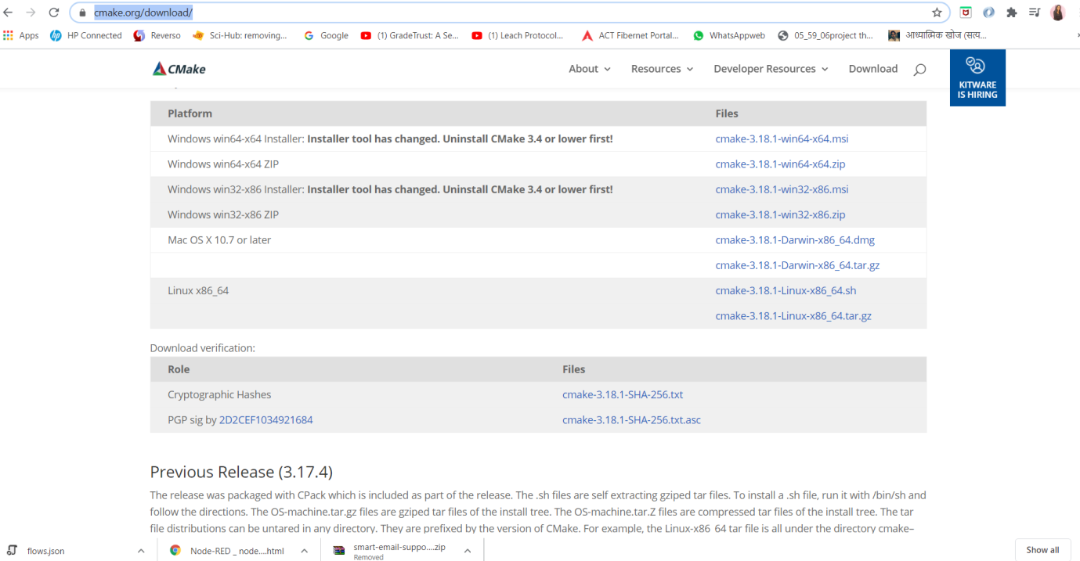

1. Make sure you install the proper version of cmake compatible with your system configuration(Click on .msi file).
2. During installation make sure you select Add Cmake to the system PATH for the current user

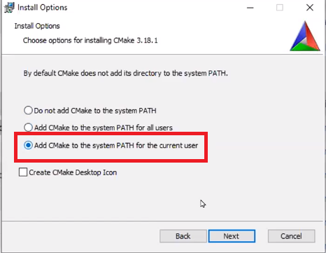

**Activity 4:Dlib,face-recognition,imutils,opencv**

1.After you install visual studio and Cmake, Open anaconda prompt from start menu .

* OpenCV --pip install opencv-contrib-python
* Imutils --pip install imutils
* Cmake --pip install cmake
* Dlib --pip install dlib
* Face-recognition –pip install face-recognition

